**Lab 2**

**Scatter plot between house size and cost**

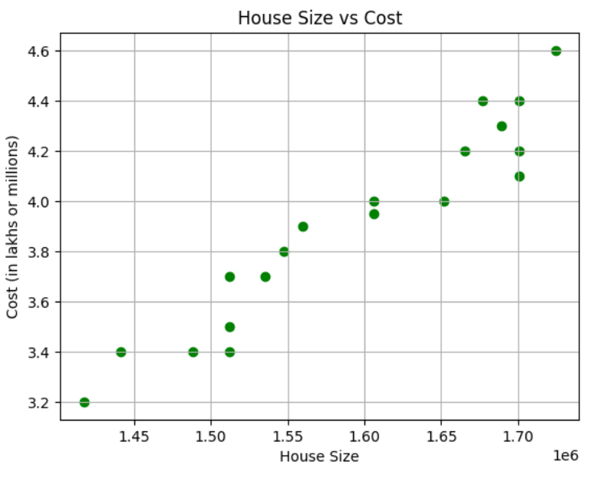

* Average SID ≈ 1582956.32
* Guess Size ≈ 1187217.24